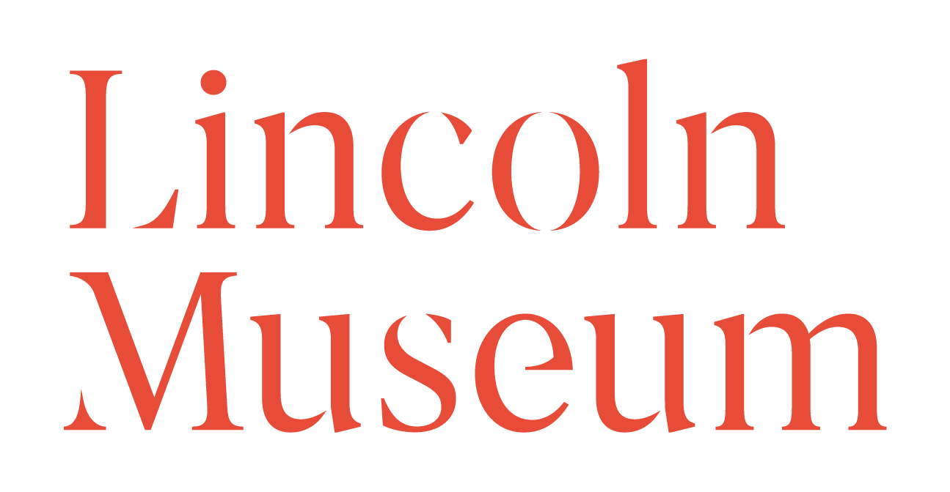

To Lincoln Museum

Re: …….…………………………………………………………………………….....

……………………………………………………………………………………….....

…………………………………………………………………………………………..

I hereby agree to donate the above artefacts to Lincoln Museum as representatives of Lincolnshire County Council Culture Service. This donation is an absolute gift to the museum without condition. I relinquish all legal claims for the ownership of the artefacts in favour of Lincolnshire County Council.

Signed …………………………………………………………………………………

Print ……………………………………………………………………………………

Position………………………………………………………………………………...

Organisation………………………………………………………………………….

Date…………………………………………………………………………………….

