Archaeology Day 23rd July 2015

BACK TO THE TROWEL

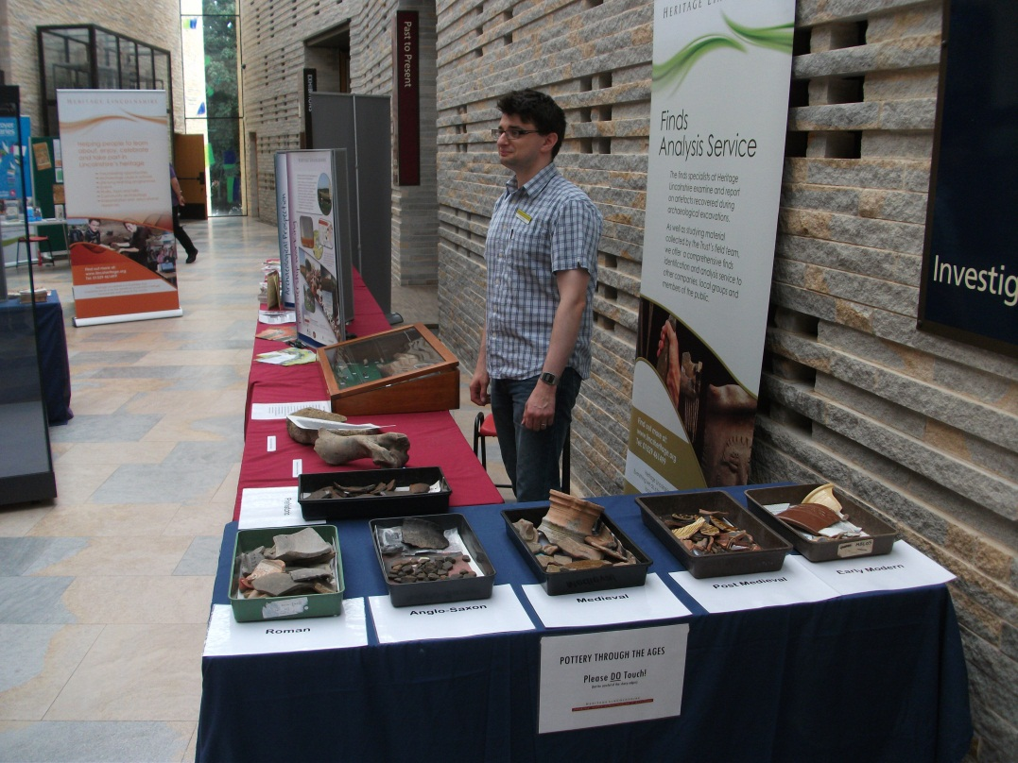

On Thursday the 23rd of July The Collection in association with Heritage Lincolnshire is hosting an Archaeology Day.

This is the Collection's third annual Archaeology Day and is run as part of the Council of British Archaeology's Festival of Archaeology in conjunction with Heritage Lincolnshire. It will run from 10am to 4.30pm. All the talks and almost all the activities are free, though some activities you do need to book on the day (we don't have the facilities to book in advance I am afraid). All the activities are subject to change and cancellation, but we hope we may even have more than what is listed below!

Last year we looked at reconstructing the past, this year there will be more of a focus on the digging. There are activities for all ages and all levels of knowledge from story time for little ones to serious talks that even the most dedicated scholar would find of interest.



Telephone 01522 782040

http://www.thecollectionmuseum.com/http://www.thecollectionmuseum.com/

http://www.thecollectionmuseum.com/

Telephone 01522 782040

http://www.thecollectionmuseum.com/http://www.thecollectionmuseum.com/

http://www.thecollectionmuseum.com/

The Museum

In the main hall of the museum there will be various stalls from lots of different archaeological groups.

Heritage Lincolnshire (in association with Lincolnshire Wolds Festival and the Layers of History Project) will have a stall with project leaflets, a books, a selection of finds for people to look at and possibly an activity to piece together a replica medieval pot.

AEMES (Ancient Egyptian and Middle East Society) will have a stall with flyers, details of future events, copies of their newsletter the Envoy and an Egyptian word search puzzle (suitable for all age groups). The Ancient Egypt and Middle East Society was founded in 1987. It meets in Lincoln welcomes all who have an interest in the history and archaeology of the peoples of the ancient Near East.

SLHA (Society for Lincolnshire Heritage and Archaeology) will have a stall selling books.

LAGER (Lincoln Archaeology Group for Excavation Education and Research) will have a stall outlining their new local archaeology projects.

OSHG Old Sleaford Heritage Group. General publicity about their project. Possibly with a pottery identification project aimed at 10-12 year olds.

TICKET DESK The Collection staff will have a stall where you can get information about the day and book the events in the Education Suite. We are also doing a craft activity (making a model Roman villa) which costs £1 a go (to cover costs) and you get the materials here.

Telephone 01522 782040

http://www.thecollectionmuseum.com/http://www.thecollectionmuseum.com/

http://www.thecollectionmuseum.com/

The Gallery

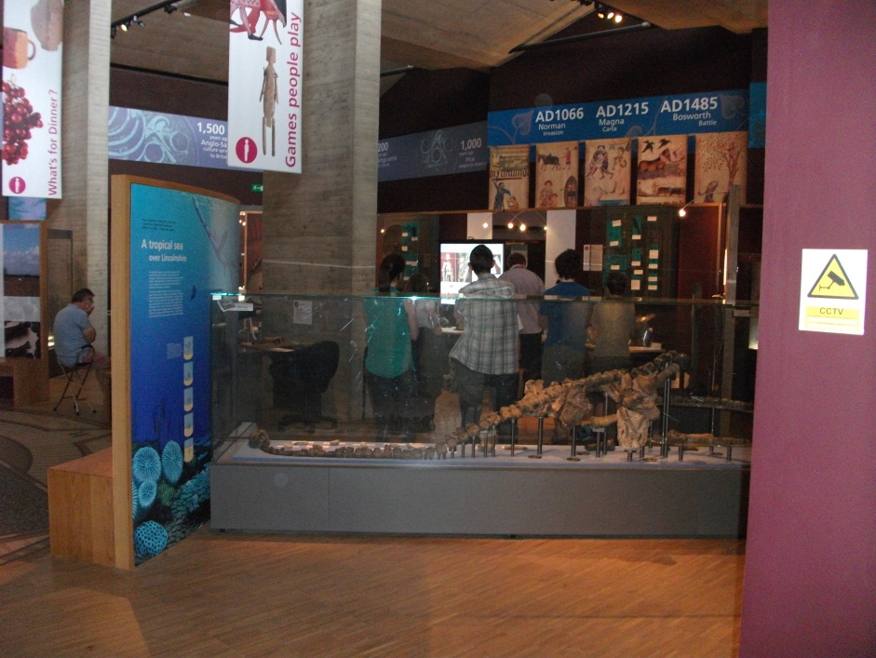

In the gallery of the museum where the archaeological finds are displayed there will be various informal and fun chats. No need to book.

11.30am A talk about experimental archaeology in the prehistoric section with our education staff. A chance to see how prehistoric man lit fires and ground corn.

1pm A Roman archaeology talk in the Gallery with Antony Lee, our Roman archaeology expert.

2pm An Anglo-Saxon archaeology talk with Dr Grigg (our Anglo-Saxon expert) talking about grave goods and what they can tell us about Anglo-Saxon dress, warfare and beliefs.

3pm A Viking talk in the gallery with our education staff. Find out how well-groomed our Scandinavian forbears wore with our education staff.

4pm A talk about evidence of trade in the medieval and early modern period with our education staff.

Telephone 01522 782040

http://www.thecollectionmuseum.com/http://www.thecollectionmuseum.com/

http://www.thecollectionmuseum.com/

Telephone 01522 782040

http://www.thecollectionmuseum.com/http://www.thecollectionmuseum.com/

http://www.thecollectionmuseum.com/

Education suite

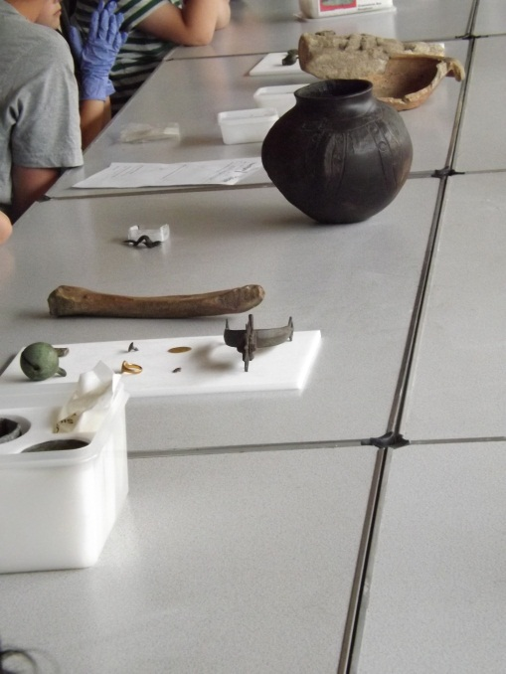

These sessions need to be booked in advance at our desk in the orientation hall. Ideal for families.

10.30 Classical archaeology training (a practice dig in big trays) in the education suite with our education staff. Ideal for younger ones.

11.30 Object handling and find identification session in the education suite run by Antony Lee.

12.30 Medieval archaeology training (a practice dig in big trays) in the education suite with our education staff. Ideal for younger ones.

1.30 Object handling and find identification session run by Alex Beeby, Senior Project Officer (Ceramics) Heritage Lincolnshire.

2.30 Archaeology training for older ones (even grownups can have a go) in the education suite with our education staff.

3.30 What does an Archaeologist do? A family-orientated session for children up to 12 years old which will look at all the different techniques archaeologists use to discover the history beneath our feet. Delivered by Eloise Markwick, Senior Project Officer (Layers of History) Heritage Lincolnshire.



Telephone 01522 782040

http://www.thecollectionmuseum.com/http://www.thecollectionmuseum.com/

http://www.thecollectionmuseum.com/

AV/ Cinema

There will be various talks in our audtiroiurm, the storytime is for little ones, the quiz for all ages but the other talks are a little more highbrow! No need to book.

10.30am Adam Daubney (Portable Antiquities Scheme) will be doing a talk on recent finds

11am Storytime with Linda for little ones with an archaeolgical theme

12 Julia Brocklehurst, David Start, David Stonehouse and Denise Wheatley will be giving talk entitled The Spirit of Sutterby about their experiences and discoveries during their community heritage project. Sutterby, tucked away in a fold in the Lincolnshire Wolds, is one of the county's many deserted medieval villages. Today there is just the tiny, redundant church of St John the Baptist, sat near a modern farm complex. We will highlight our recent community excavation which explored the successive rebuilding of the west end of Sutterby Church.

1pm Margaret Beaumont from AEMES (Ancient Egyptian and Middle East Society) will be giving a talk entitled Living and Dying in Ancient Egypt and Mesopotamia. Since the early 19th Century, the discoveries made by explorers and excavators have increased our knowledge of these two great empires which left their mark on the Ancient World. Though similar in many ways, both based on mighty rivers, they had very different views of the world they lived in. From their monuments and possessions we can understand something of how these people lived and worked, their family lives, the kings which ruled them, the gods which they believed had made their world and how they prepared for the afterlife they expected.  Margaret holds the Certificate in Egyptology from the University of Manchester.

2pm Interactive History Quiz with prizes suitable for all the family delivered by Liz Bates, CEO Heritage Lincolnshire.

3pm Brian Porter from LAGER (Lincoln Archaeology Group for Excavation Education and Research) will be giving a talk on their recent projects including work at Sudbrooke, our test pit project along Ermine Street, followed by the Medieval Graffiti Project and examples found so far in Lincolnshire Churches.

4pm Tom Lane from Old Sleaford Heritage Group (OSHG) will be giving a talk outlining the considerable known archaeology of Old Place, Sleaford and putting it in its landscape context.



Telephone 01522 782040

http://www.thecollectionmuseum.com/http://www.thecollectionmuseum.com/

http://www.thecollectionmuseum.com/

Telephone 01522 782040

http://www.thecollectionmuseum.com/http://www.thecollectionmuseum.com/

http://www.thecollectionmuseum.com/

Usher Gallery

In the Clore education room LAGER (Lincoln Archaeology Group for Excavation Education and Research) will be hosting some activities for younger budding archaeologists.

There will be the skeleton activity where kids get to dig up a human skeleton (it is not real I am assured) which was buried with grave goods and record their finds.

There will also be a Forensic Facial Reconstruction activity is using plastic skulls and clay to reconstruct faces. This is suitable for children of all ages.

Telephone 01522 782040

http://www.thecollectionmuseum.com/http://www.thecollectionmuseum.com/

http://www.thecollectionmuseum.com/